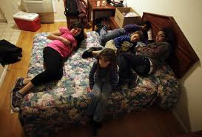
Why are people who live in motels considered to be homeless?
Serving the Community by;

People living in motels meet the Federal definition of homelessness, which states that anyone living in "inadequate nighttime housing" is considered to be homeless. Families, often with 4 or more members, must all conduct their daily lives in one room, with a dismaying lack or privacy, dignity or safety.
“If your actions inspire others to dream more, learn more, do more and become more, you are a leader.” ~ John Quincy Adams
RESTORING DIGNITY Now, Inc.
Help US: 804-243-5106 or e-mail Restoringdignity@ymail.com
The motels are anything but adequate for housing needs.
Contrary to popular belief, the majority of individuals and families living in motels are quite simply the working poor. They are not accepting aid and do have jobs--minimum wage jobs which do not generate the income necessary to pay rent and bill along with all the other necessities it takes to maintain a home.
The slippery slope to homelessness gets steeper for all of us every day. Contrary to popular belief not everyone becomes homeless by bad or immoral decisions. Job shutdowns, layoffs, medical and natural disasters are all significant contributing factors.
Life is enough of a struggle when you are poor and homeless.
Families living in Motels are the most misunderstood and underserved of all homeless.

As the gap between housing costs and living wages grows further apart, more & more people are finding themselves unable either to maintain or even find affordable housing.

On any given night in at a City or Private Shelter, there are between 25,000 to 30,000 homeless individuals. With strict rules, restrictions, and limited space, the working poor often don’t get a spot.

Without the motels, the working homeless would have nowhere at all to go!

